**Schematics**

**of**

**AVRGait – Analyse, Visualise and Report**

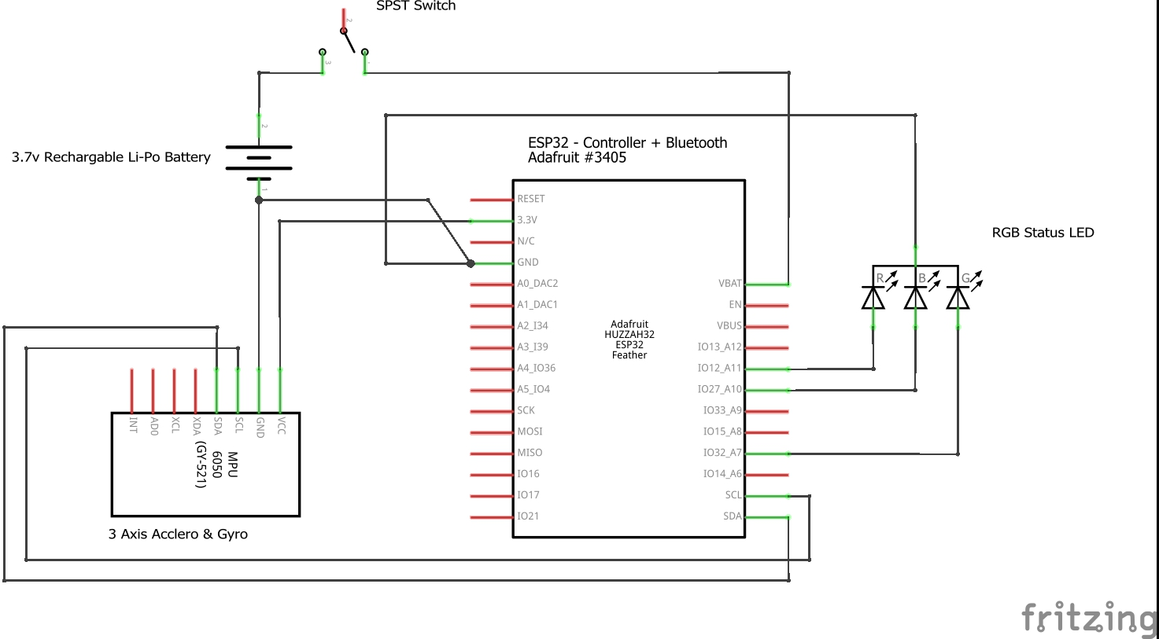

**Graphical view of AVRGait prototype**

